Learn a language!!
Register today!
Kindergarten and 1st grade
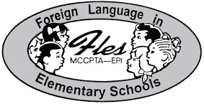

Your school PTA is sponsoring an exciting language program called FLES. Language classes for Kindergarten and First Grade will meet once a week for 10 weeks beginning in January 2005. The fee for 10 lessons is $70.00 per child.

language | level | day | time
Spanish | Introductory | Monday | 8:15 am to 9:00 am
Chinese | Introductory | Wednesday | 3:30 pm to 4:30 pm

To register your kindergarten or first grade child:
- Complete this form and attach a check made payable to your school’s PTA.
- Bring both to the PTA FLES envelope in your school’s office by January 18, 2005
- Your Coordinator is Frank Samuelson Email: frank@merrill-samuelson.com
Daytime phone: 301-443-5020 ext. 126 Evening phone: 301-770-1530
- Coordinator will confirm all classes and start dates. Registration is on a first come, first served basis and the FLES program fee is non-refundable. Checks will be returned if course is not offered.

(please detach and save top for your records)
- - - - - - - - - - - - - - - - - - - - - - - - - - - - - - - - - - - - - - - - - - - - - - - - - - - - - - - - - - - - - - - - - - -
2005 FLES Registration Introductory Program

Language: (please circle)  Spanish Chinese | Child’s Grade and Teacher:
Child’s Name:

Child’s Home Address:

Parent’s Name: Email: Telephone:

Who will Pick-up child after class for pm classes?

Emergency Contact: Telephone: Cell:

Payment Amount Enclosed: Date:

